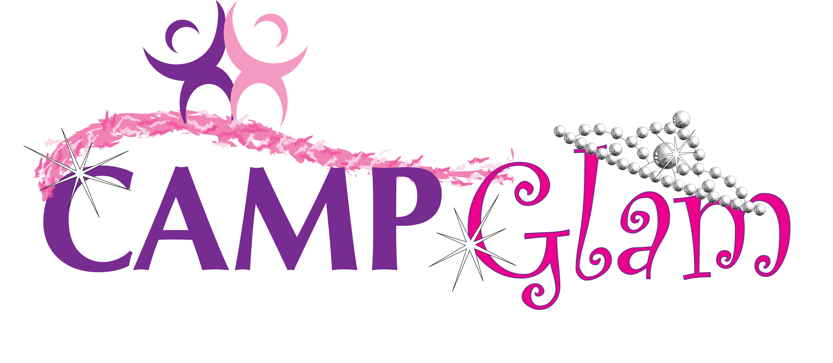

Name: __________________________________________

Week 1: June 17- June 19*  Girly Clinic: Diva Boot Camp Theme: Wild Wild West |  | W R F
Week 2: June 22- June 26  Girly Clinic: Accessorize It! Theme: Ghosts & Goblins |  | M T W R F
Week 3: June 29 - July 3  Girly Clinic: America’s Best Dance Crew Theme: Superhero Galaxy |  | M T W R F
Week 4: July 6- July 10  Girly Clinic: Fun With Fashion Theme: Olympic Games |  | M T W R F
Week 5: July 13- July 17  Girly Clinic: Broadway Star Theme: Pirates of the Caribbean  *Field Trip: Broadway Show |  | M T W R F
Week 6: July 20- July 24  Girly Clinic: Pamper Yourself Theme: Pajama Jammy Jam |  | M T W R F
Week 7: July 27- July 31  Girly Clinic: Rockstar Theme: MTV Music Video Awards |  | M T W R F
Week 8 : August 3- August 7  Girly Clinic: Beach Bums Theme: Maui Waui  *Field Trip: Jersey Shore |  | M T W R F
Week 9: August 10-August 14  Girly Clinic: Beauty Inside and Out Theme: Wet ‘N’ Wild  *Field Trip: Splash World |  | M T W R F
Week 10: August 17- August 21  Girly Clinic: A Picture is Worth a Thousand Words Theme: Survivor |  | M T W R F
Week 11: August 24- August 28  Girly Clinic: Incredible Edibles Theme: Jungle Safari |  | M T W R F
Week 12: August 31- Sept 4  Girly Clinic: Girl Talk Theme: Carnival |  | M T W R F

